
Faculty of Science and Technology
420-431-VA Application Development 2 (Mobile)

Project Proposal

Local Helpers

Team members
Willkerdy Elveus
Amine
Daiyan Abrar Samin

Table of Contents
Project Concept and Description 3
Concept 3
Description 3
Requirements 4
Functional requirements 4
All: 4
Seeker: 4
Hero: 4
Admin: 4
Nonfunctional requirements 4
Security: 4
Usability: 4
Technology Stack 5

Project Concept and Description

Concept
Our idea for the Application Development 2 course is to make a mobile app platform where local residents (Seekers) can connect with neighbors/helpers (Heroes) to receive help with small, medium or large tasks. This app is made to help people who have difficulty in finding jobs or just need a small side hustle to get extra money. It also helps people who can’t do a certain task themselves. By providing a secure, easy to use platform, Local Helpers creates community connections and helps out people in need.

Description
Local Helpers will be developed using Flutter, targeting both IOS and Android systems. The application will feature three different user portals: Seeker, Hero and Admin. Seekers can post tasks, browse available heroes, and complete payments. Heroes can discover nearby tasks, manage their schedule, and track earnings. The admin handles user verification, analytics, and everything else related to the backside of the app.

Requirements

Functional requirements

All:
- Users can register and log in using email/password
- Users can select their role (Seeker, Hero) during signup
- Users can create and edit their profile
- Seekers/Heroes can chat with each other.
- Push notifications are sent for new tasks, updates and messages
- Users can reset their password via email

Seeker:
- Seeker can post a new task
- Seeker can view a map or list of current heroes and browse their profile
- Seeker can complete payment after task completion and add a tip
- Seeker can rate and give reviews about the heroes

Hero:
- Hero can view a list of open tasks
- Hero can sort task with different options
- Hero can manage accepted tasks through a calendar view or list view
- Hero can view their earnings dashboard with charts

Admin:
- Admin can view all users and verify Hero accounts
- Admin can resolve problems, manage task categories

Nonfunctional requirements

Security:
User data will be stored using firebase authentication and Fire store security rules. Passwords will be hashed.

Technology Stack
Component | Tool
Frontend | Flutter (Dart)
Backend | Firebase
Authentication | Firebase Auth
Version Control | GitHub
Design | Figma
Testing | Android Studio emulator

https://github.com/Wlszn/localheroes.git
https://www.figma.com/make/PKTcKVxfgsgFgOoDI7fAIE/Local-Helpers-App?t=2RG56xq5uDr5QXNN-1&preview-route=%2Fonboarding

Screen Flows

Splash Screen
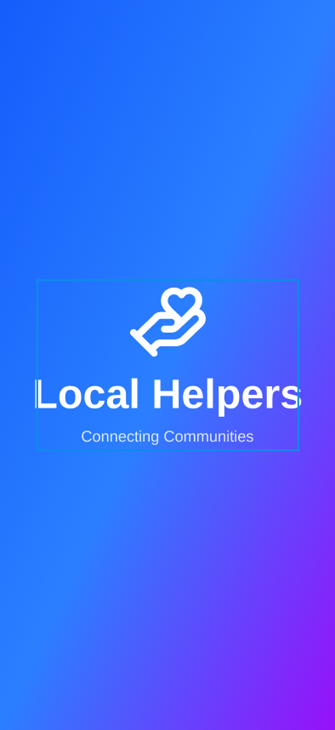

Onboarding Screens

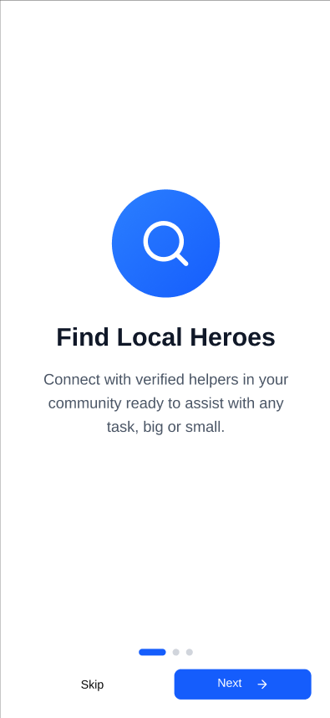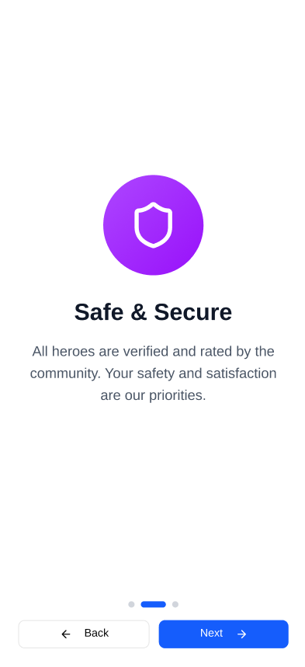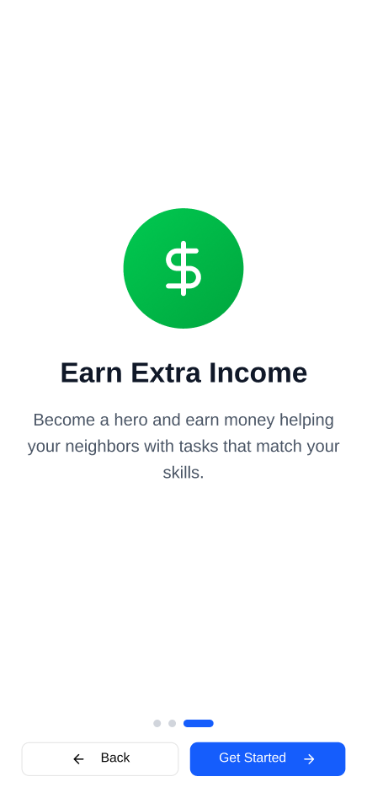

Role Selection
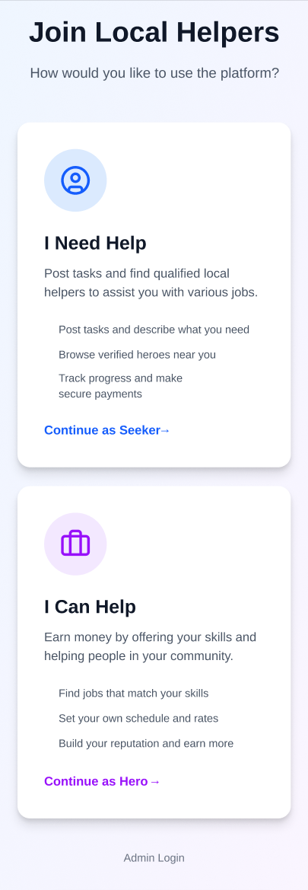

Signup/Login
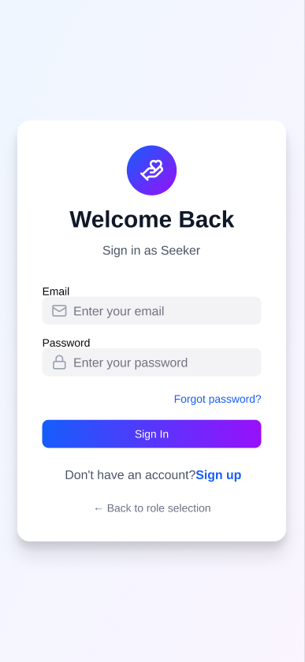

Profile setup
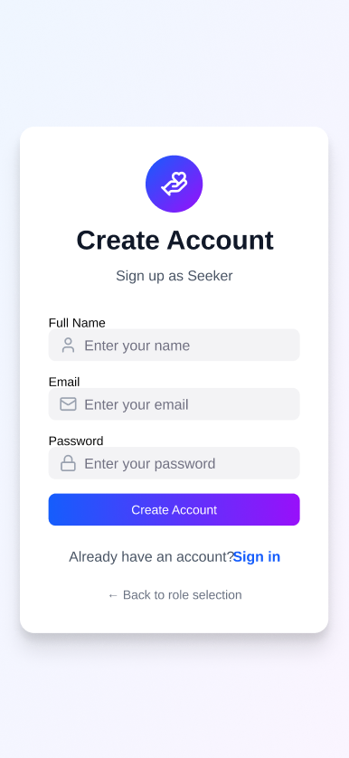

Map
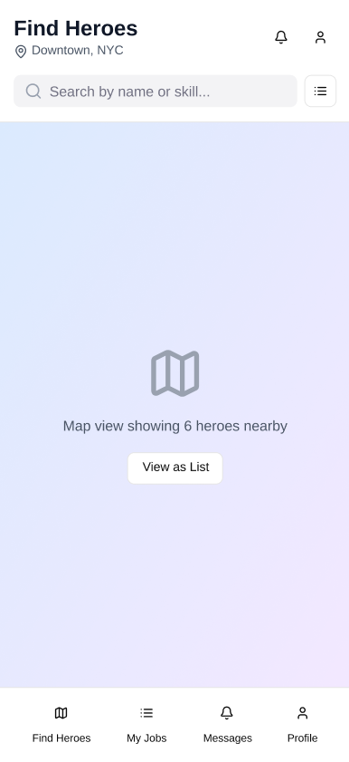

Task Form
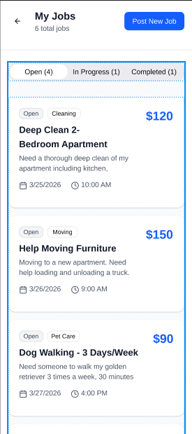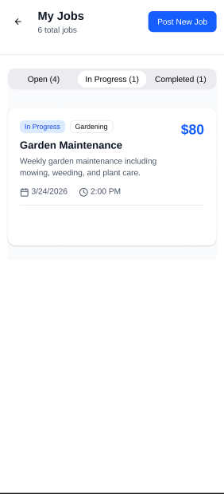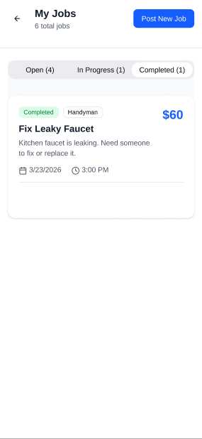

Browse heroes

Messages
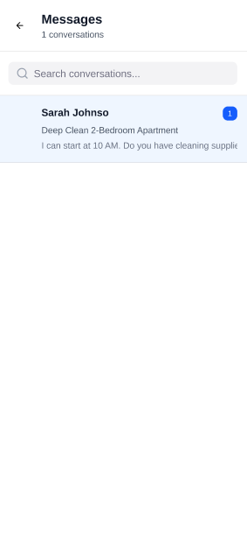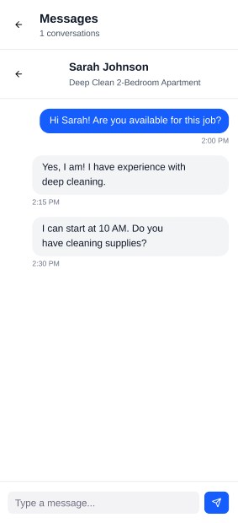

Profile
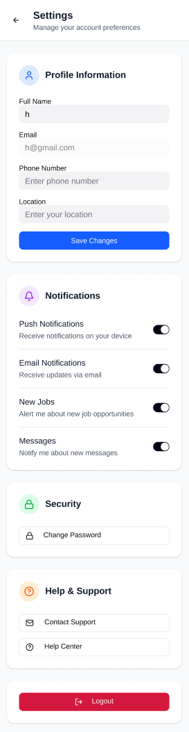

Task lists
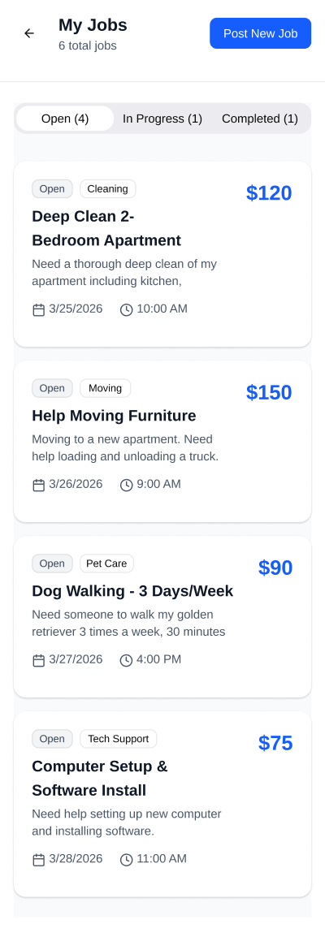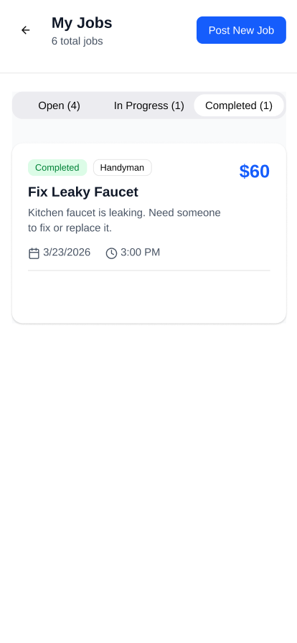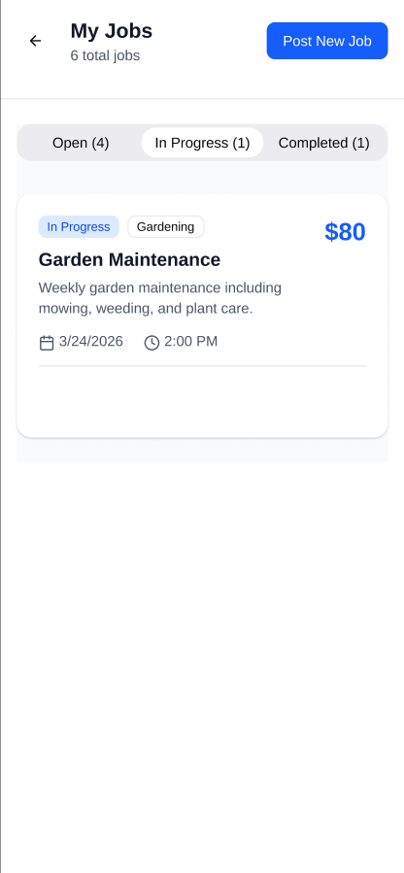

Job details
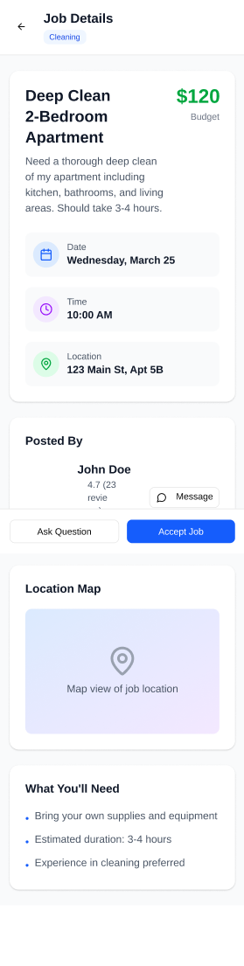

Hero Schedule
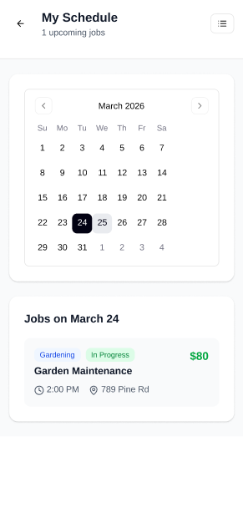

Payment Screen

Rating & Review
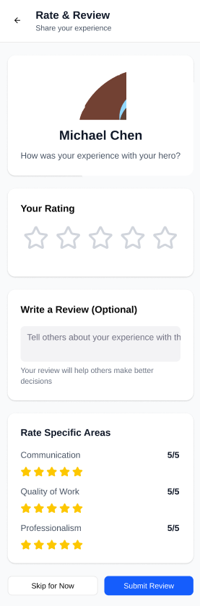

- Dashboard
- Admin Dashboard
- Settings/ Forget password

Mockup Design

Pictures go here when design is done

